

Data Technician

Name:
Course Date:
Table of contents
Day 1: Task 1 2
Day 1: Task 2 2
Day 2: Task 1 3
Day 2: Task 2 3
Day 3: Task 1 4
Day 3: Task 2 5
Day 4: Task 1 6
Day 4: Task 2 7
Course Notes 7
Additional Information 8

Day 1: Task 1

Please research the different versions of Tableau, compare and contrast them below and explain the limited functionality on ‘Tableau Public’.

Different Tableau versions
  Version | Description | Key Features
  Tableau Public | A free version of Tableau which is use for creating and sharing visualisations online | Its cloud-based storage, basic visualisations, and publicly accessible dashboards only.
  Tableau Desktop | A paid professional software for creating rich, interactive visualisations. | Full analytics suite, data blending, local storage, export options, Python/R integration.
  Tableau Server | A paid version. It is an enterprise platform for sharing, managing, and collaborating on dashboards. | It is hosted on-premises, Web authoring capabilities, secure sharing within the organisation, and user access controls.
  Tableau Online | Tableau manages the cloud-based version of Tableau Server. | No server setup needed, accessible from anywhere, and secure data sharing.
  Tableau Reader | A free desktop app, use for viewing Tableau dashboards created in Tableau Desktop. | Read-only access to Tableau files, interactive filters, but no editing or saving
  Tableau Prep | A paid tool use for preparing and cleaning data before visualisation. | Data cleaning, reshaping, merging, and visual workflows for ETL (extract, transform, and load) tasks.
  Tableau Mobile | A free version of Tableau server/cloud, used to access and interact with dashboards on the go.  It is dependent on Tableau Server/Cloud. | Interactive viewing and some filtering.

Day 1: Task 2

Using the EMSI_JobChange_UK dataset, create your own dashboard, I want to see a bar chart showing percentage change and a UK based map showing the key city locations impacted.

Paste your print screen here | 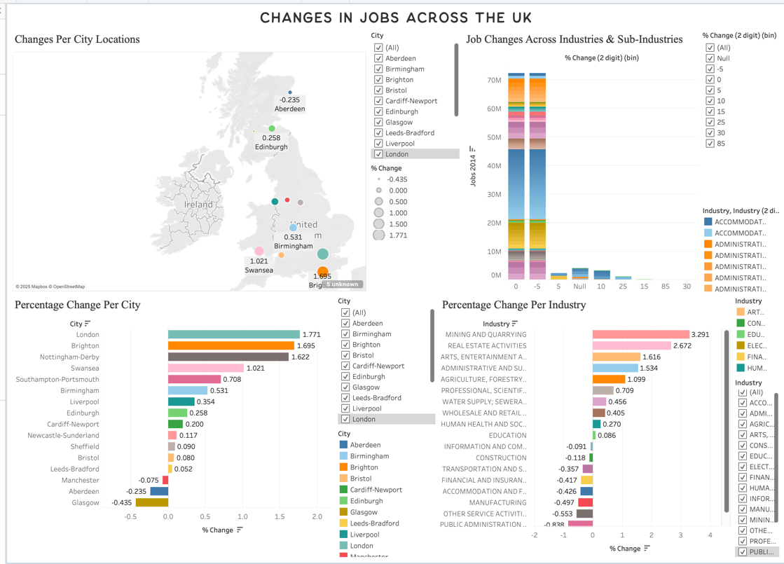

Day 2: Task 1

Using the Spotify data set, conduct an analysis to find trends and key information that could be used by an organisation for future projects.

There is no set scope for the analysis, simply to find trends and document them below:

Paste your print screens here | 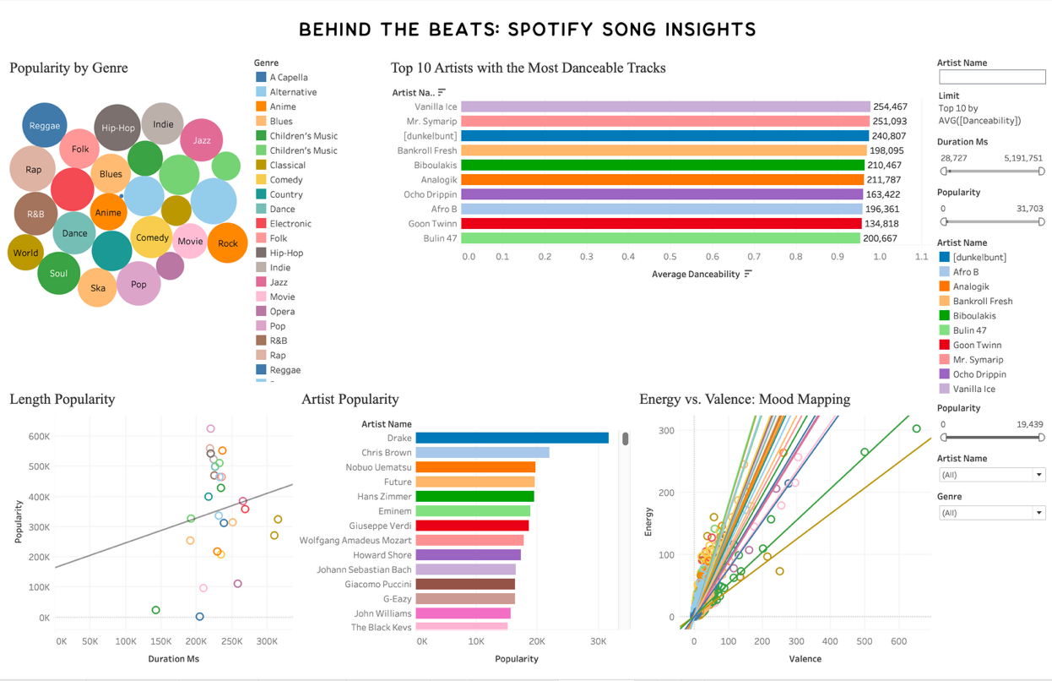

What did you find? | During the analysis, I found that songs with higher danceability generally had higher popularity scores, suggesting that more danceable tracks perform better. Certain artists consistently produced highly danceable and popular songs, especially when filtered to those with multiple tracks. Overall, the analysis highlighted that energetic, moderately loud, and danceable songs tend to be more successful on Spotify.

Day 2: Task 2

Using the Health, conduct an analysis to find trends and key information that could be used by an organisation for future support.

There is no set scope for the analysis, simply to find trends and document them below.

- Data can be lifesaving and is being used more within the NHS, reflect on how this data could support decision making for the NHS.

Paste your print screens here | 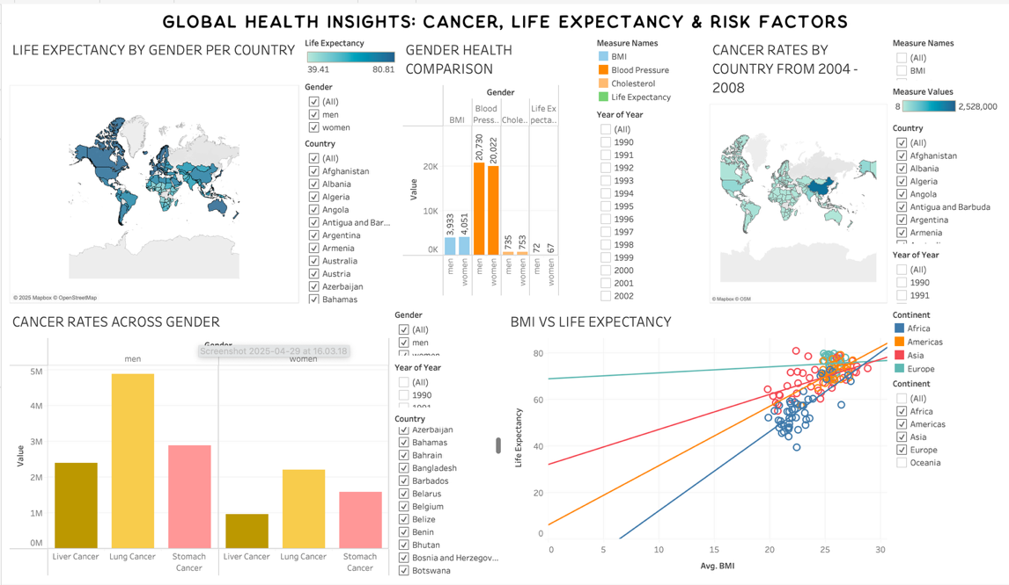
What did you find and any reflections on how the NHS could use this?

Day 3: Task 1

Please complete Lab 1 ‘Get Data in Power Bi Desktop’. Once complete, paste a print screen below and in the collaboration board.

“Teaching is the best way to learn, so please listen out for support requests from the class and we’ll work through the challenges together”

Paste your completed lab here | 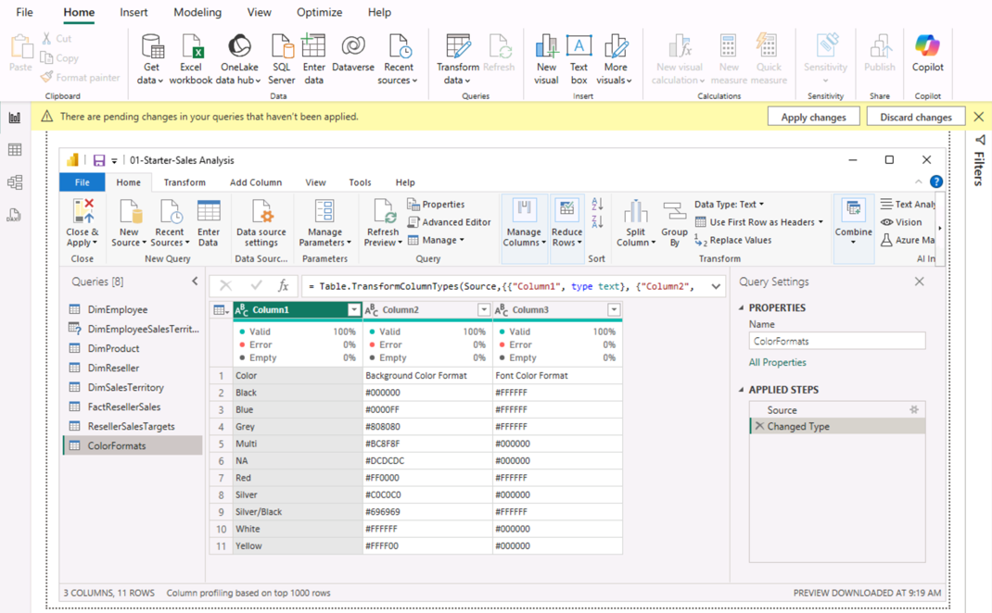

Day 3: Task 2

Please complete Lab 2 ‘Load Transformed Data in Power BI Desktop’. Once complete, paste a print screen below and in the collaboration board.

“Teaching is the best way to learn, so please listen out for support requests from the class and we’ll work through the challenges together”

Paste your completed lab here | 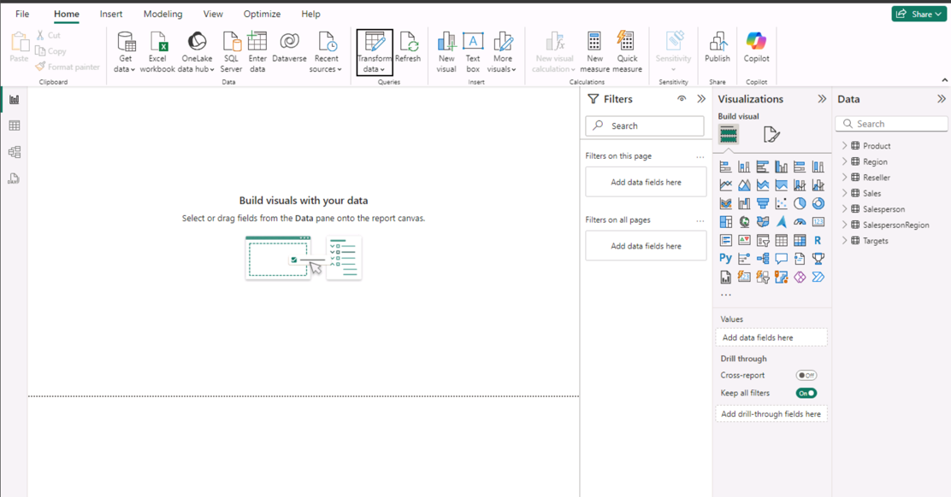

Day 4: Task 1

Please complete Lab 6 ‘Design a Report in Power BI Desktop’. Once complete, paste a print screen below and in the collaboration board.

“Teaching is the best way to learn, so please listen out for support requests from the class and we’ll work through the challenges together”

Paste your completed lab here | 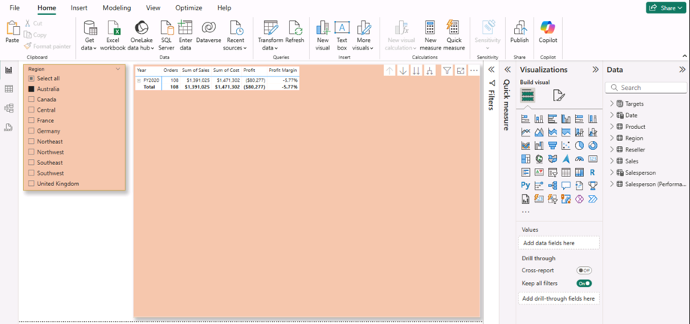  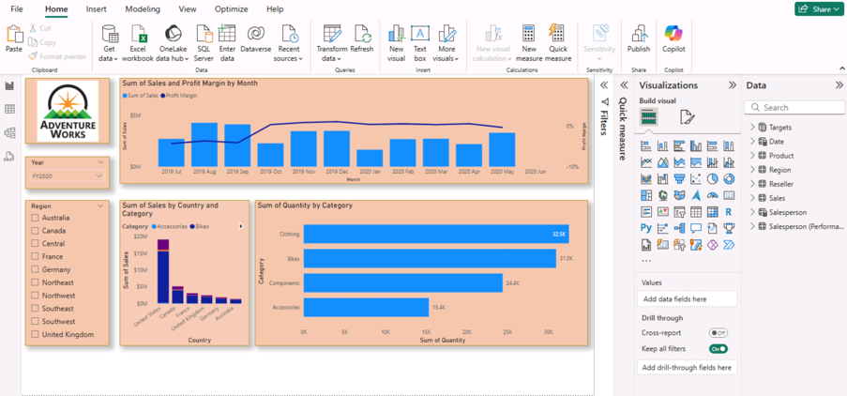  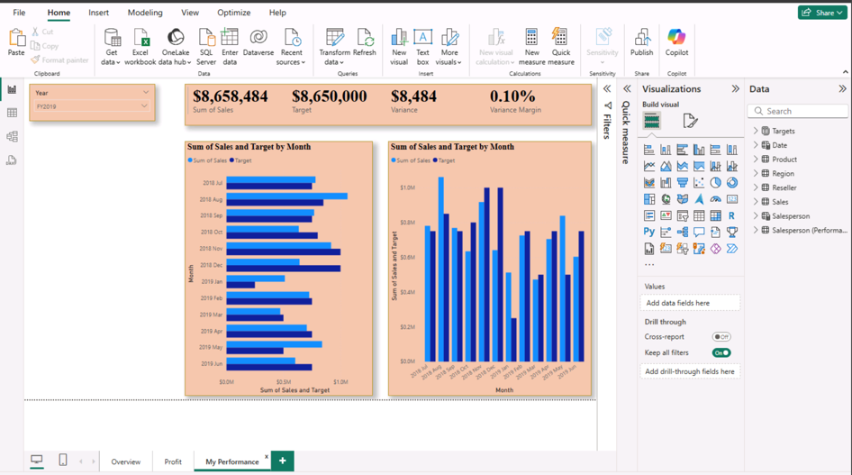

Day 4: Task 2

Please complete Lab 10 ‘Create a Power BI Dashboard’. Once complete, paste a print screen below and in the collaboration board.

“Teaching is the best way to learn, so please listen out for support requests from the class and we’ll work through the challenges together”

Paste your completed lab here | 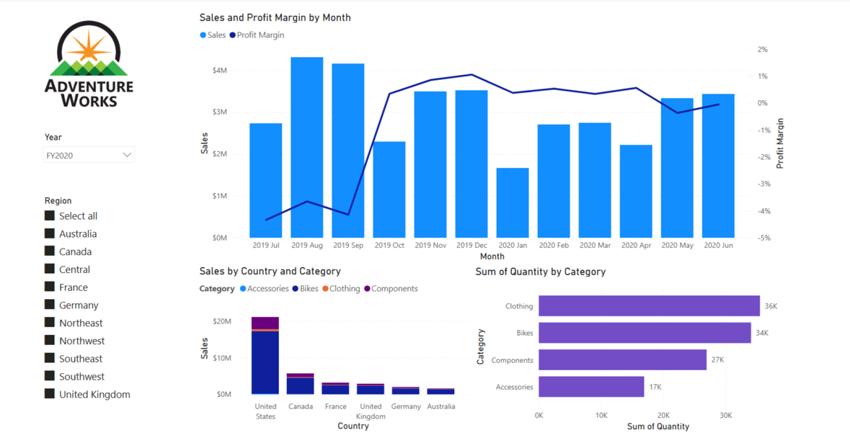  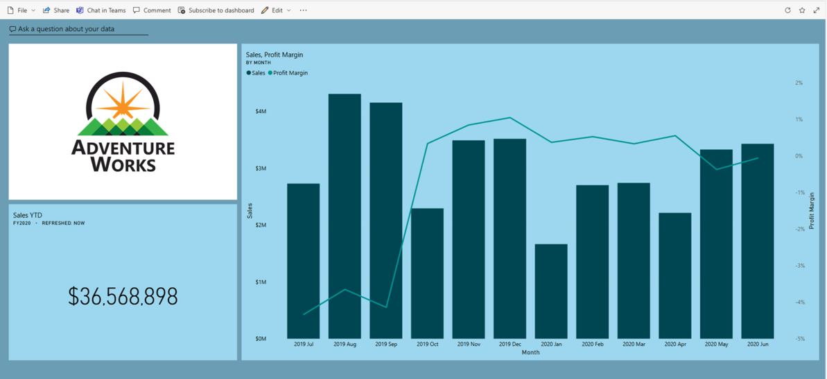

Course Notes

It is recommended to take notes from the course, use the space below to do so, or use the revision guide shared with the class.

We have included a range of additional links to further resources and information that you may find useful, these can be found within your revision guide.

END OF WORKBOOK

Please check through your work thoroughly before submitting and update the table of contents if required.

Please send your completed work booklet to your trainer.

Information

